**Name :- Rahul Maurya UID:- 20BCS7260**

**Class/section:- 716A subject :- CN lab**









 



 



 

 The ping command is used to test connectivity between two hosts.

 ping google.com



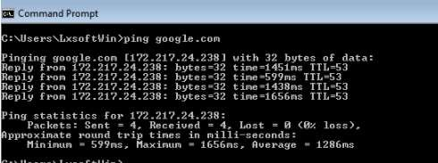

 This command displays all current TCP/IP network configuration values and refreshes Dynamic Host Configuration Protocol (DHCP) and Domain Name System (DNS) settings







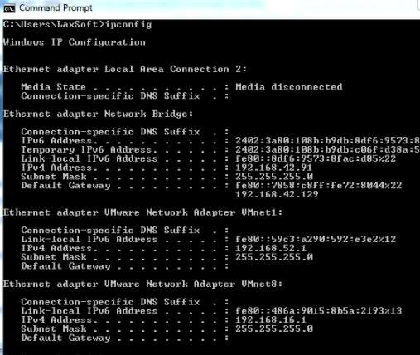

3. This command is used to diagnose path- related problems.







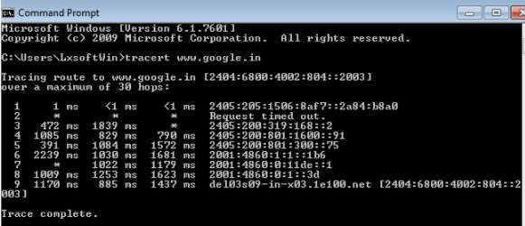

4. : NSLookup is a great utility for diagnosing DNS name resolution problems. Just type the NSLookup command, and Windows will display the name and IP address of the device’s default DNS server.

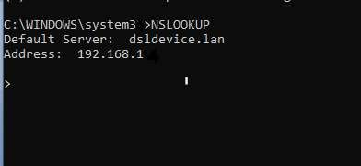



  This command displays active connections, ports on which the computer is listening, Ethernet statistics, the IP routing table, and IP statistics.

COMMAND: netstat OUTPUT:

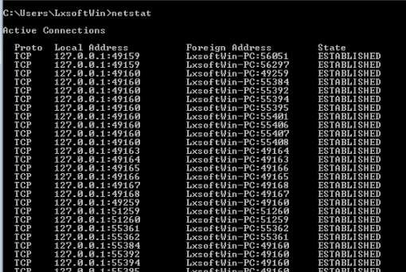

 The ARP command corresponds to the Address Resolution Protocol. Although it is easy to think of network communications in terms of IP addressing, packet delivery is ultimately dependent on the Media Access Control (MAC) address of the device’s network adapter.

COMMAND: Arp -a OUTPUT:

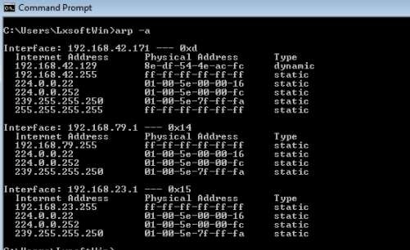

7.  Typing Hostname at the command prompt returns the local computer name.

COMMAND: hostname OUTPUT:

